Role title: | Cloud & Infrastructure Domain Architect | Responsible to: | Lead Solution Architect
Division: | Technology, Digital and Data (TDD) | Department: | Engineering & Architecture
Direct Reports and Level: | No Direct reports | Scope: | Architecture and Design
 | No Direct reports | Scale: | N/A
 | No Direct reports | Regulated Function(s) Held: | No
Evaluation Level | Implement 1 | Role Family | Digital, Data, Change

Overall Role Purpose
The Cloud & Infrastructure Domain Architect is responsible for designing and governing enterprise-grade cloud and when required, on-premises infrastructure. They are also responsible for the design, governance and continual improvement of End User Computing of desktop, device and application delivery platforms. This role ensures that technology platforms are secure, scalable, cost-optimised and aligned to MPS overall strategy.
The role defines and maintains the domain strategy, target state architecture, designs, patterns and standards governing the enterprise cloud estate, hybrid infrastructure, enterprise networking (including SD-WAN), EUC/Desktop and telephony and contact centre infrastructure platforms.
Operating within Architecture & Engineering and reporting to the Lead Solution Architect, the role translates enterprise architectural direction into domain-level architectural standards and actionable roadmaps. The role does not define enterprise-wide strategy but ensures that Cloud and Infrastructure architecture is aligned to it.
The role:
- Owns the architectural integrity of the Microsoft Azure estate, ensuring alignment to Microsoft Well-Architected Framework (WAF) principles
- Defines and governs reference architectures for hosting, networking, connectivity and infrastructure resilience
- Establishes domain guardrails to ensure scalable, secure and cost-effective infrastructure design
- Acts as the authoritative subject matter expert and internal consultant to Solution Architects across delivery towers
- Provides architectural assurance and sign-off for infrastructure-related designs
The role works in close partnership with key stakeholders in the Technology Operations function, to ensure alignment between architectural intent and operational capability, while maintaining independence in architectural governance.
The role collaborates with other Domain Architects to ensure coherent cross-domain architecture and alignment to enterprise architectural standards.

Accountabilities (RACI) | Measures of Success/KPI’s
Operational  - Define and maintain the Cloud & Infrastructure domain strategy aligned to enterprise architectural direction.  - Own and evolve the target state architecture and transition roadmap for Azure, hybrid infrastructure, enterprise networking and telephony platforms.  - Develop, publish and govern domain blueprints, patterns, standards and guardrails aligned to Microsoft Well-Architected Framework (WAF) principles.  - Provide architectural oversight and formal assurance for infrastructure, network and telephony designs within delivery towers and programmes.  - Act as the Cloud & Infrastructure subject matter authority, consulting to Solution Architects during HLD and LLD development.  - Ensure cross-domain alignment with Security, Data and Integration architectures to deliver coherent end-to-end solutions.  - Partner with IT Operations to ensure architectural standards are operable, scalable and sustainable, while maintaining independence of architectural governance.  - Identify emerging infrastructure and cloud trends and assess applicability to the domain roadmap. | - Approved and maintained Cloud & Infrastructure domain strategy and roadmap.  - Publication and adoption of domain blueprints, standards and reference architectures.  - % of delivery initiatives aligned to approved Cloud & Infrastructure patterns (design conformance rate).  - Reduction in non-standard or bespoke infrastructure implementations.  - Demonstrable alignment of Azure architecture to Microsoft Well-Architected Framework principles.  - Stakeholder feedback from Solution Architects and IT Operations on clarity and effectiveness of architectural guidance.  - Evidence of infrastructure simplification and technical debt reduction influenced by architectural direction.  - Timely production of architectural artefacts in line with governance checkpoints.
Financial  - Provide architectural input into business cases where Cloud and Infrastructure design decisions impact cost, resilience, scalability or long-term sustainability.  - Define and promote cost-optimised cloud architecture patterns aligned to FinOps principles and Microsoft Azure cost governance best practice.  - Advise on infrastructure investment decisions to ensure alignment with domain strategy and target state architecture.  - Support financial planning by identifying opportunities for platform rationalisation, consolidation and technical debt reduction.  - Ensure architectural standards minimise duplication, unnecessary hosting costs and bespoke infrastructure solutions.Contribute domain insight to annual planning cycles and investment prioritisation discussions. | - Evidence of cost optimisation embedded within domain standards and patterns.  - Reduction in avoidable cloud consumption inefficiencies attributable to architectural guidance.  - Reduction in duplicate or non-standard infrastructure solutions.  - Positive variance between estimated and actual infrastructure costs where architectural input was provided.  - Documented architectural input to business cases and investment proposals.  - Clear infrastructure roadmap aligned to agreed financial planning cycles.
Member  - Ensure Cloud and Infrastructure architecture enables secure, resilient and performant member-facing services.  - Design infrastructure standards that support service availability, scalability and business continuity requirements.  - Ensure telephony and contact centre infrastructure architectures support reliable member engagement channels.  - Promote architectural decisions that enhance service stability and reduce disruption risk to members.  - Ensure infrastructure evolution supports digital capability growth and improved member experience outcomes. | - Infrastructure designs demonstrably aligned to resilience and availability standards.  - Reduced risk of member-facing service disruption due to architectural weaknesses.  - Positive stakeholder feedback from business and operational leaders on infrastructure enablement.  - Clear alignment between domain roadmap and member-facing service priorities.  - Architecture artefacts reflect defined availability, continuity and resilience requirements.
People  - Act as the Cloud & Infrastructure domain authority, providing clear architectural direction and expert guidance across delivery towers and programmes.  - Build trusted working relationships with Solution Architects, IT Operations, Security, Data and Integration Domain Architects to ensure coherent cross-domain outcomes.  - Provide constructive challenge where proposed designs deviate from agreed standards or introduce unnecessary complexity or risk.  - Contribute to the continuous development of architectural capability within Architecture & Engineering through knowledge sharing, mentoring and pattern reuse.  - Maintain up-to-date professional knowledge in cloud, infrastructure, networking and telephony technologies and practices.  - Take accountability for own continuous professional development and adherence to architectural governance processes. | - Positive feedback from Solution Architects and domain peers on clarity and effectiveness of architectural guidance. Increased reuse of approved infrastructure and network patterns across initiatives.  - Evidence of early architectural engagement in delivery initiatives.  - Reduction in design rework caused by late-stage infrastructure challenges.  - Maintenance of relevant certifications and continuous professional development.  - Constructive participation in governance forums and architectural communities of practice.
Risk  - Own architectural controls within the Cloud & Infrastructure domain to ensure solutions are secure, resilient and aligned to regulatory expectations.  - Define and govern infrastructure, network and telephony standards that reduce risk exposure across availability, security, performance and scalability.  - Ensure alignment of domain architecture to Microsoft Well-Architected Framework (WAF) principles and agreed security standards.  - Provide architectural assurance at governance checkpoints to prevent the introduction of unmanaged technical, security or resilience risks.  - Collaborate with the Security Domain Architect to ensure secure-by-design infrastructure and network patterns.  - Identify architectural risks arising from non-conformance, technical debt or platform complexity and escalate appropriately.  - Ensure infrastructure and connectivity designs support business continuity and disaster recovery requirements.  - data protection and IT security. | - % of infrastructure designs compliant with approved domain standards.  - Reduction in risk findings linked to infrastructure or network architectural weaknesses.  - Clear documentation of architectural risks and mitigation strategies within governance artefacts.  - Evidence of alignment between Cloud & Infrastructure standards and Security domain controls.  - Reduction in legacy or unsupported infrastructure patterns introducing systemic risk.  - Timely escalation of architectural risks impacting enterprise stability.

Responsibilities (RACI)
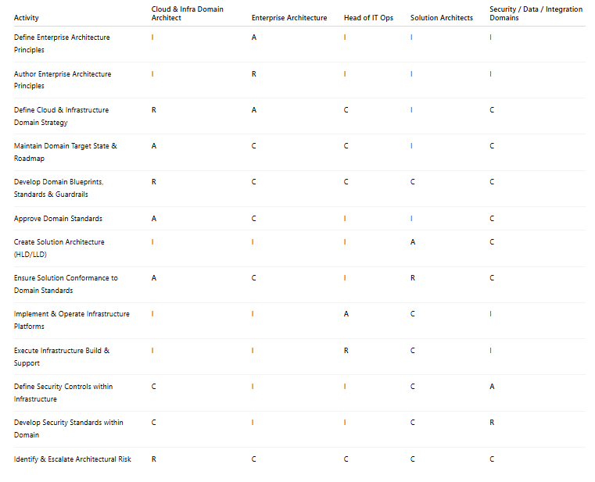

Key Governance Responsibilities

- Represent Technical Design Authority (TDA), representing the Cloud & Infrastructure domain.
- Provide architectural assurance and formal sign-off for solution designs impacting cloud, infrastructure, networking and telephony platforms.
- Ensure adherence to approved domain standards, guardrails and target state architecture.
- Escalate material non-conformance or architectural risk where domain integrity is compromised.
- Provide architectural advisory input to CAB for changes materially impacting infrastructure or connectivity.
- Collaborate with peer Domain Architects to ensure coherent cross-domain architecture and regulatory alignment.

Leadership Framework Competencies | Level
Fresh Thinking | Leading others
Building Capability in Self and Others | Leading others
Influencing Others | Leading others
Collaborating for Results | Leading others
Commercial and Risk Thinking | Leading others
Leading Self and Others | Leading self
 | Knowledge and Qualifications | Skills | Experience
Essential | Deep expertise in Microsoft Azure architecture, including landing zone design, identity integration, networking, resilience and cost governance.  Strong understanding of Microsoft Well-Architected Framework (WAF) principles and their practical application.  Experience designing hybrid infrastructure environments, including enterprise networking and SD-WAN architectures.  Understanding of modern telephony and contact centre infrastructure platforms.  Strong knowledge of infrastructure security controls including IAM, network segmentation, encryption and regulatory considerations.  Clear understanding of federated architecture operating models and domain governance structures. | Ability to define domain strategy and translate enterprise direction into actionable architectural standards.  Strong architectural assurance capability, including constructive challenge and design validation.  Ability to operate at both strategic (target state / roadmap) and detailed design levels.  Strong stakeholder engagement skills across Architecture, IT Operations and delivery teams.  Ability to influence without direct line authority.  Structured documentation and blueprint development capability.  Ability to identify and articulate architectural risk clearly and objectively. | Proven experience as a Cloud, Infrastructure or Platform Architect within a complex enterprise environment.  Experience owning domain standards and providing architectural governance within delivery lifecycles.  Experience supporting Solution Architects within a federated architecture model.  Experience operating within regulated or risk-managed environments.  Experience aligning infrastructure architecture to operational capability without assuming operational ownership.
Desirable | Microsoft Azure certifications (e.g. Azure Solutions Architect Expert or equivalent).  Familiarity with architecture frameworks such as TOGAF. | Experience with EA modelling tools. | Experience within insurance or similarly regulated sectors.

